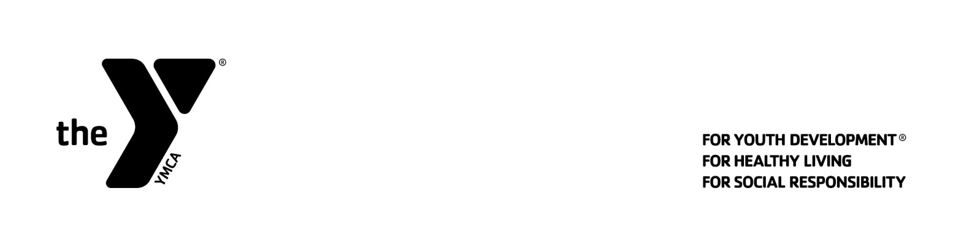
What to Bring to Day Camp
YMCA Camp Hanes
BRING:
- Wear casual comfortable clothes that you do not mind getting dirty
- Change of clothes
- Bathing Suit
- Closed Toe Shoes
- Water Shoes
- Towel
- Water Bottle
- Sunscreen
- Bug spray
- Medication (if needed)
- Money (if camper want to visit Camp Store, Friday only)
DO NOT BRING:
- Valuables
- Glass
- Weapons
- Pets/animals
- Alcohol/ Drugs
- Electronics (may be used for bus ride only)

* Camp Hanes is not responsible for lost items. We collect all lost and found items on Friday and have them in our laundry facilities until the end of August. At that time we will donate items to the Camp Hanes camper closet.

